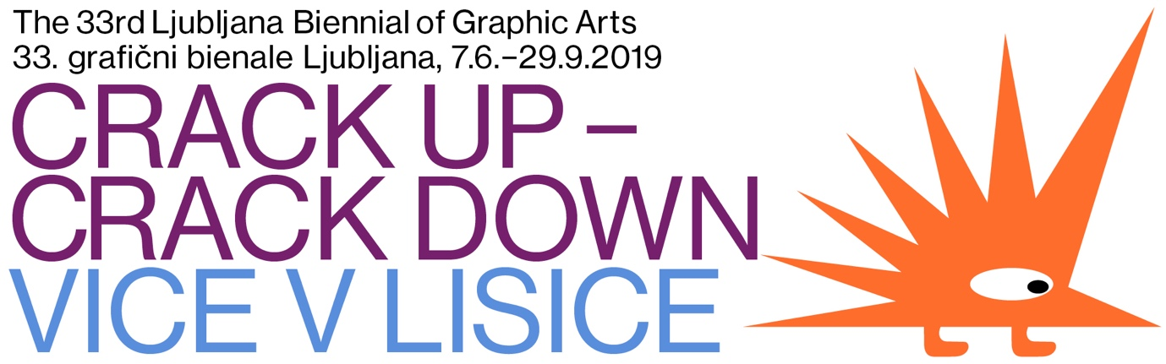

How alive is satire today?

The 33rd edition of the Ljubljana Biennial of Graphic Arts will be a critique, but expressed in a comic and scornful manner, given that its main topic will be the genre of satire. The focal Slovenian international exhibition, which will be opened to the public at the International Centre of Graphic Arts in Ljubljana on 7 June, is being curated by the Slavs and Tatars art collective this time and bears the title Crack Up – Crack Down. The exhibition will live at nine locations within the city!
The Biennial will present a specific graphic language of the invited artists, who are attempting to use irony and ridicule to stimulate the emergence of highly resilient and topical forms of criticism and infra-politics. Namely, by placing a mirror to power and telling the truth, satire has proven itself to be a petri dish in a world of post-truth bacteria. The exhibition will address the satire genre in the present day from several viewpoints. Besides the historical aspect, it will also showcase the works of contemporary artists, including the interventions of various activists and new-media polemicists, as well as the performances of stand-up comedians and others. In the 33rd edition of the Biennial, the Slavs and Tatars art collective considers the graphic not only as a medium but rather in its ability to act as an agency. If the accessibility of printing at the beginning of the 20th century led to the unimpeded expansion of the satirical periodicals (Pavliha in Slovenia, Simplicissimus in Germany, Punch in the UK, l'Assiette au Beurre in France or Molla Nasreddin in the Caucasus, to name but a few), the fertile ground of the graphic in today’s digital age reveals itself in the form of the meme or protest poster. New aesthetic languages have emerged from the visual saturation of our time.
The artists taking part in the Biennial come from Slovenia, Poland, Ukraine, Georgia, Bulgaria, China, Iran, Great Britain and the USA. The curators of this year’s Biennial, the Slavs and Tatars art collective, have prepared a selection of artists that use their own unique graphic languages within a range of diverse practices.
The exhibition will be enriched by a series of accompanying events and a publication that will, in addition to presenting the satirical and graphic practices, include the contributions of well-known experts and academicians and will introduce the reader to the subject and guide him through it.

